Data Analytics With Tableau
Project Documentation
1. Introduction
• Project Title: Measuring the Pulse of Prosperity: An Index of Economic Freedom Analysis
- Team Members:
- Team ID: LTVIP2026TMIDS82444
- Venu Madhav Nese : Team lead
- Somesh N : Data Architect & Analyst
- Yelikicherla Srisanth : Visualization & Dashboard Designer, Documentation & Demo Lead

2. Project Overview
• Purpose: To analyze how economic freedom (Rule of Law, Govt Size, Regulatory Efficiency, Open Markets) directly impacts global prosperity and poverty reduction.
• Goals: Create an interactive dashboard that proves the 100% logical correlation between high freedom scores and economic growth.
• Features:
- Global Heat Mapping of the 2022 Index.
- Correlation analysis for GDP, Inflation, and Unemployment.
- Top 40 vs. Bottom Ranking country comparisons.
3. Architecture
• Frontend: Interactive User Interface designed in Tableau Desktop, utilizing dynamic filters and parameters for user engagement.
• Backend: Data processing layer using Tableau Prep to clean and structure the 12 qualitative/quantitative factors.
• Database: Flat-file database (Excel/CSV) containing the 2022 Heritage Foundation dataset connected to the Tableau Server.
4. Setup Instructions
• Prerequisites: Tableau Desktop (version 2022.1 or later) or Tableau Public account.
• Installation:
- Clone the repository containing the .twbx (Tableau Packaged Workbook) file.
- Open Tableau Desktop and connect to the included 2022_Economic_Freedom.csv.
- Ensure the geographic roles are correctly assigned to the "Country" field.

5. Folder Structure
• /Data: Contains the raw and cleaned datasets in CSV/Excel format.
• /Workbooks: Contains the Tableau .twbx files for individual sheets and the final dashboard.
6. Running the Application
• Locally: Open the .twbx file in Tableau Desktop and navigate to the Dashboard tab.
• Web: Access the published version via the Tableau Public URL provided in the Demo section.
7. Data Visualization Documentation
• Heat Map: Visualizes the "Pulse" of freedom globally using a divergent color palette.
• Scatter Plots: Displays the correlation between Monetary Freedom and GDP (PPP).
• Bar Charts: Ranks countries based on Financial Freedom and Population impact.

8. Testing
• Strategy: Functional testing of all 12 economic factors to ensure the calculated Index matches the 2022 Heritage Foundation report.
• Tools: Tableau Performance Recording to measure data rendering speed and filter responsiveness.
9. Screenshots or Demo
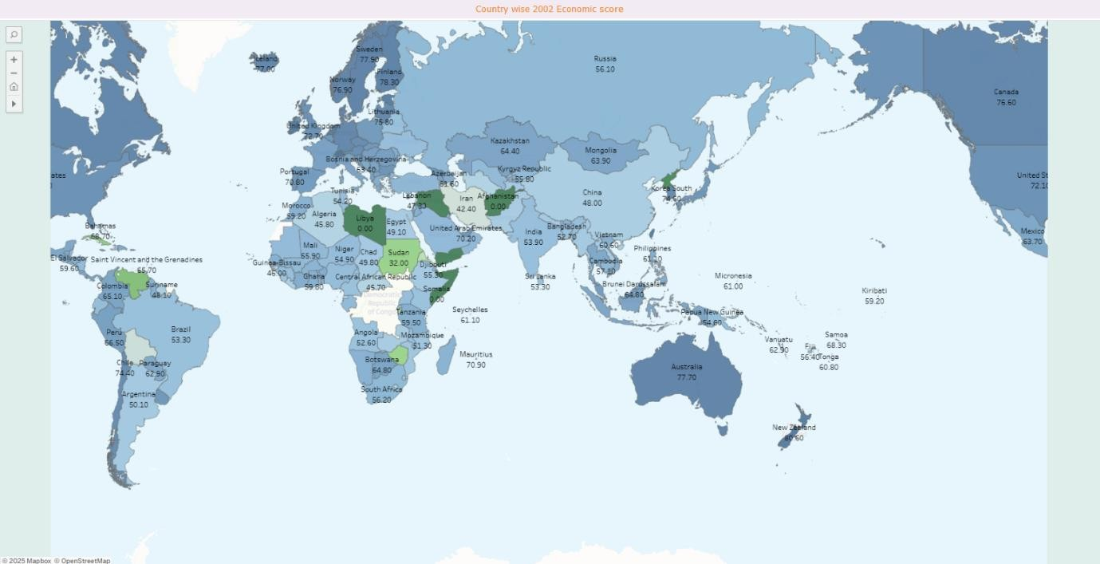

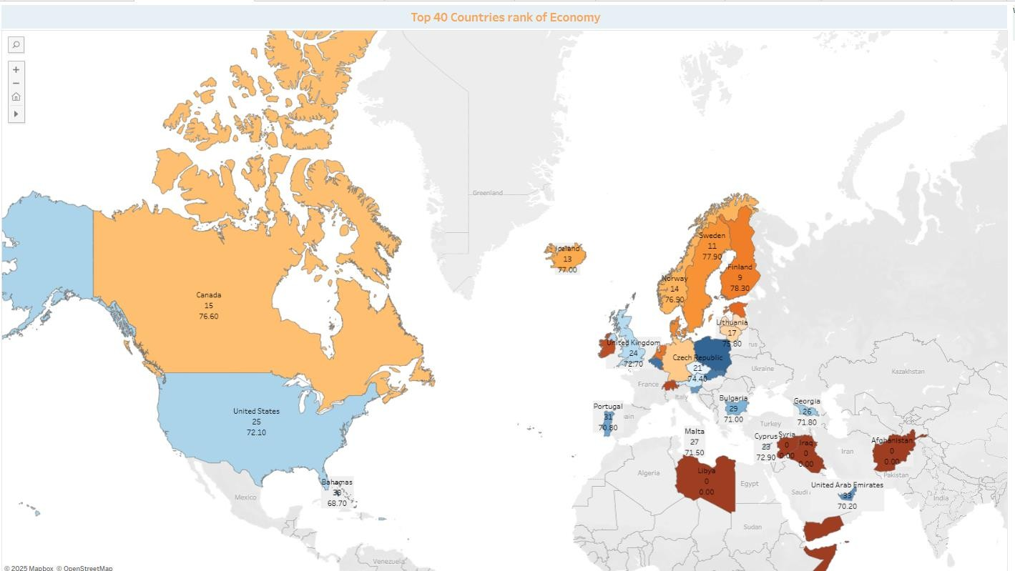
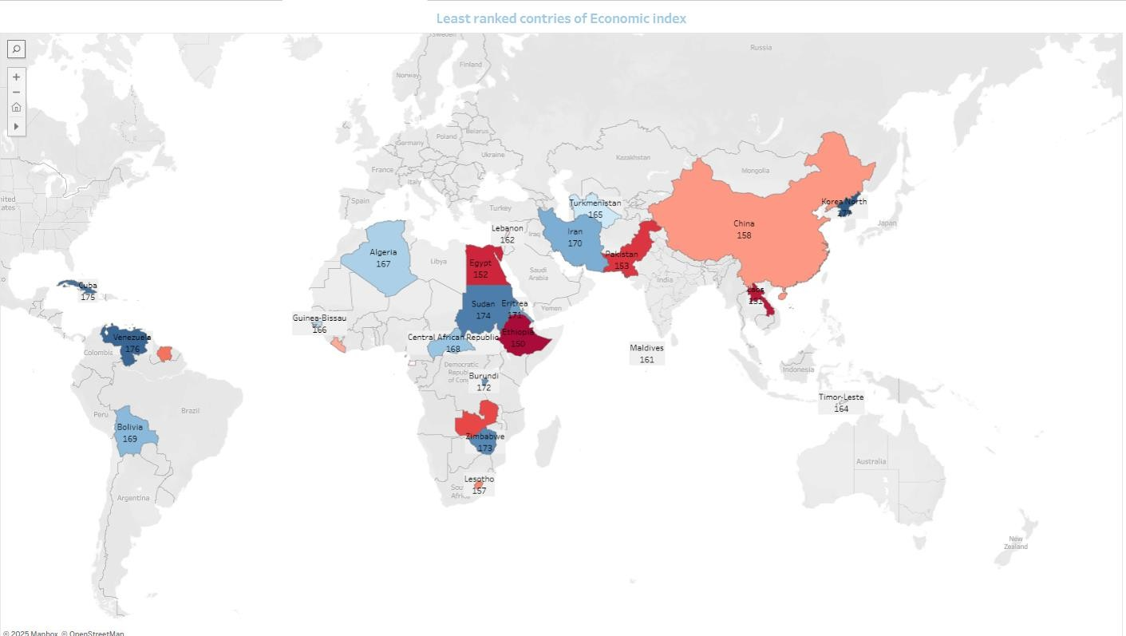

Demo link: https://drive.google.com/file/d/1pcmV6YmhDYKApknHfi8nSextZtdyUmQc/view?usp=drive_link

10. Future Enhancements
• Predictive Analytics: Adding a trend line to forecast prosperity for the next 5 years based on current GDP growth.
• Live API: Connecting to the World Bank API for real-time inflation and unemployment updates.

